CareerX 2.0 Assessment

MERN Stack (MongoDB, Express, React, Node)

# Technologies

MongoDB

Mongoose

Express

React

Node

## Er Diagram

It's a simple 2 collection database

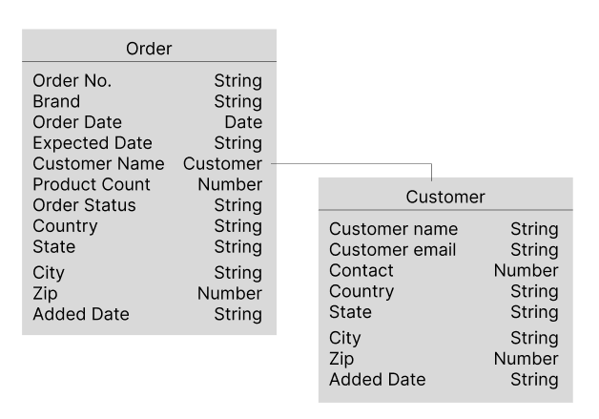

When Project is the open first page you see is a list of customers available

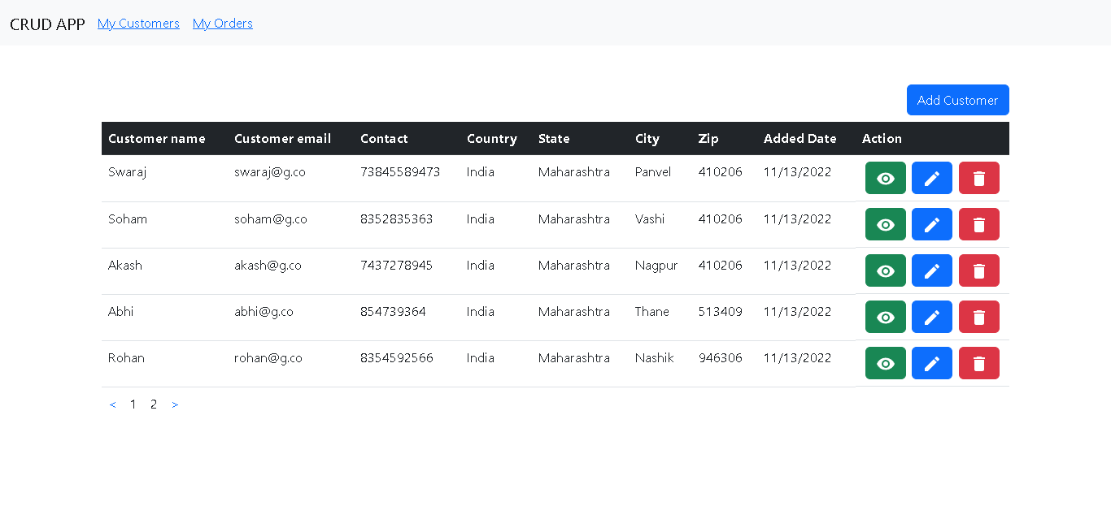

Eye button is to view customer details

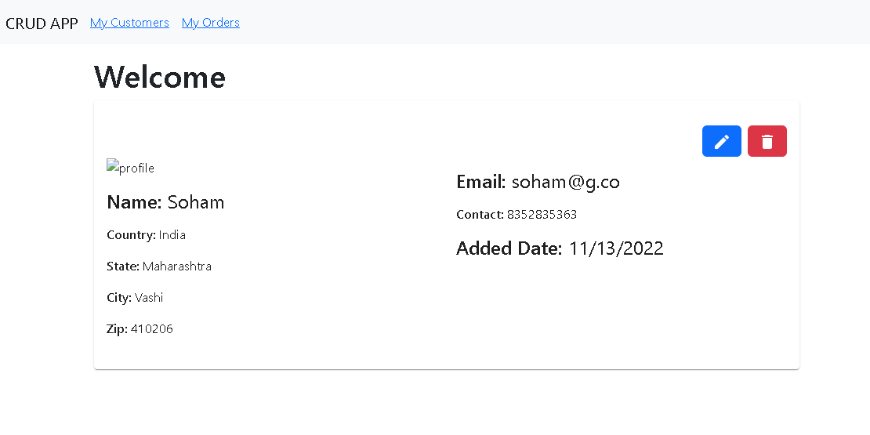

Pencil button to edit customer

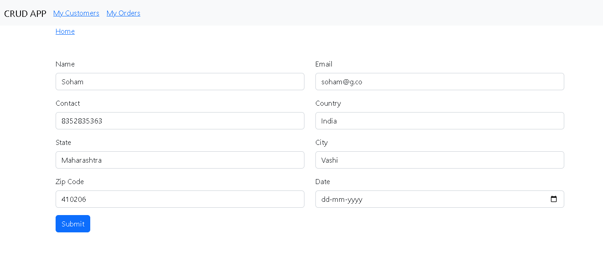

Trash button to delete customer

You can also add a new customers by clicking on the “Add Customer” button

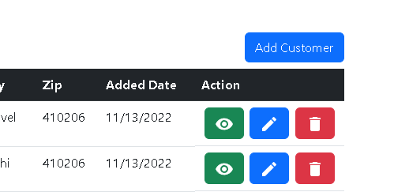

Click on My order will take you to the orders list where you will see a list of orders

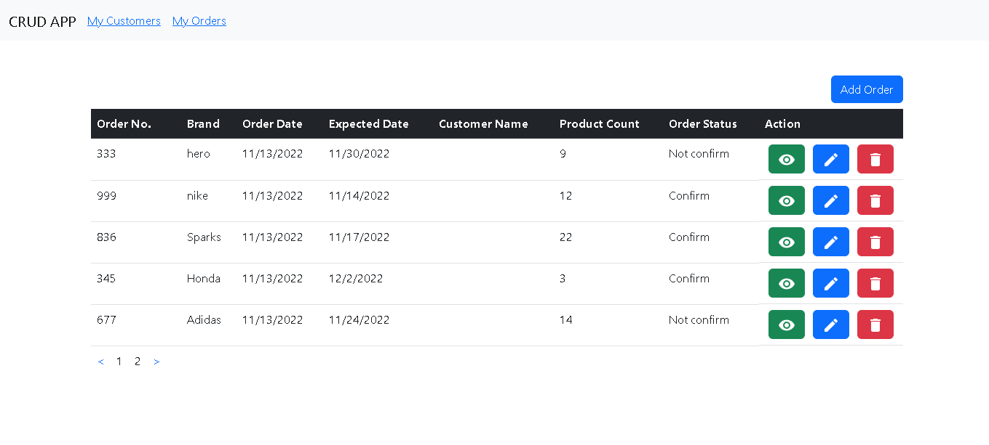

Eye button, Pencil button and Trash button do the same operation as the previous page

You can add new order by clicking on the “Add Order” button

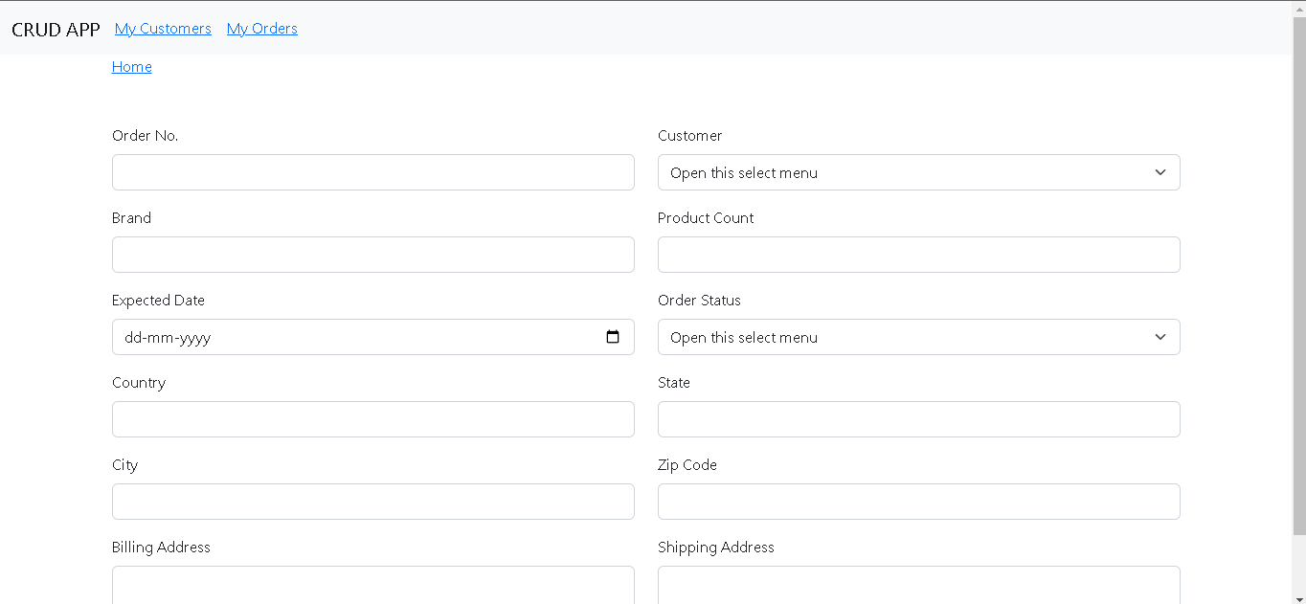

Here in the customer field you can select the customer from the Customer list

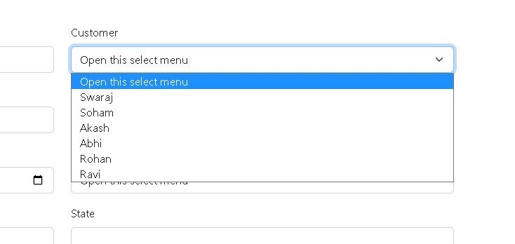

Whichever customer you add in the customer list will be shown here

### All the Operations asked in the assessment are working

But there is only one thing that I am not able to figure out

When you see the order list

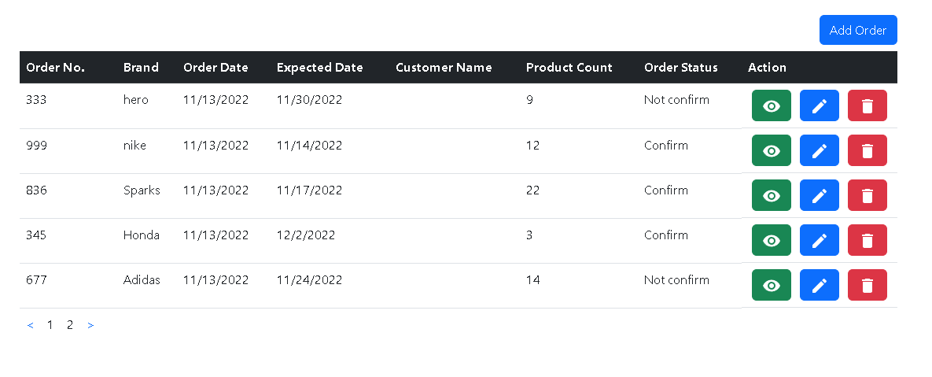

You will notice that the Customer Name column is blank

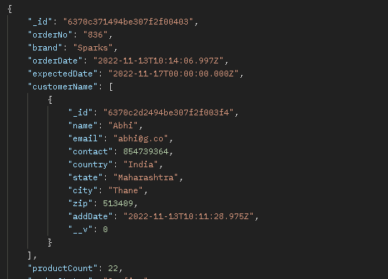

This is the screenshot of the postman

You can see data of customer Abhi from the customer list gets added here

But not getting displayed on the frontend

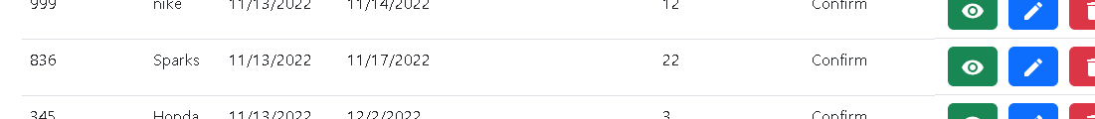

And customer id gets displayed on the order details page

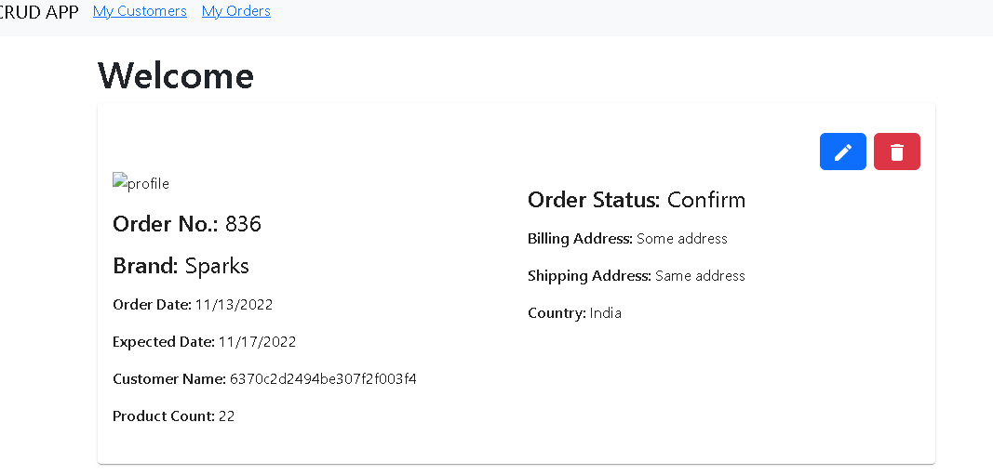

Other than that everything is working properly.

Thank You